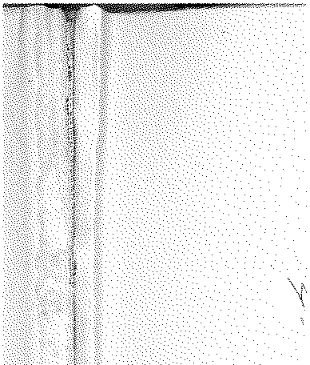

# Annual Vol ume of

TH E LAW S



# of Western N igeria

1962

## containin g

the Laws of Western Nigeria

and subsidiary legisla tion made thereunder



LOS ANGELES COUNTY

LAW LIBRARY

**W.N.L.N.** 367 of 1962

### **The** Local Government Law (Cap. 68).

THE CONTROL OF DR UMMING ADOPTIVE BYE,LAWS, 1956 AGEGE DISTRICT COUNCIL

DATE OF COMMENCEM'.ENT; 2Z:r-.1l NOVEMBER, 1962

### B 681

NOtice is hereby ghren that in exercise of the powers cOnferred upon the Agege District Council by sections 83 (2) and 276 of the Local Government Law, Cal'. 68, the Agege District Council in accordance with section 83 (3)

1. of the said Law has resolved at its meeting held on the 30th day of May,

1962, that the Control of Drumming Adoptive Bye-laws (Amendment) W.R.L.N. Order, 1957, be adopted and that the Agege District Council, Control of 297 ot1957• Drumming Adoptive Bye-laws, published . as W.R.L.N. 286 of 1956, be

amended· by substituting the following for the First and Third Schedules thereof :-

Sakarn Apala Batakoto

FIRST SCHEDULE

Mambo/Agidigbo Iyo Ilu or Dundun

Juju

Kete or Agasa

THIRD SCHEDULE

*Descriptian f Drum Period Fees*

|  |  |  |  |
| --- | --- | --- | --- |
|  | | *s* | *d* |
| Sakara | For any period between 6 a.m. to 6 p.m. | 6 | 0 |
|  | For any period between 6 p.m. to 6 a.m. | 11 | 0 |
| Iya Ilu or Dundun | For any period between 6 a.m; to 6 p.m. ... | 3 | 0 |
|  | For any period between 6 p.m. to a.m. | 7 | 0 |
| Kete or Agasa | For any period between 6 a.m. to 6 p.m. | 3 | 0 |
|  | For any period between 6 p.m. to *Ir* a.m. | 6 | 0 |
| Batakoto .,, | For any period bet¥.rcen 6 a.m, tO 6 p.m | 3 | 6 |
|  | For any period between 6 p.m. to 6 a.m. | 7 | 0 |
| Apala/Juju | For any period between 6a.m. to 6 p.m. | 3 | 0 |
|  | For any period between 6 p.m. to 6- a.m. ... | 6 | 0 |
| Mambo/Agidigbo | For any period between 6 a.m. to 6 p.m. | 6 | 0 |
|  | For any period between 6 p.m. to 6 a.m. | 11 | 0 |

DATED this 24th day of August, 1962.

* 1. K. AoEYEMt,

#### Chairman, A.gege District Council

J. OLU foE,

#### Secretary, Ag,ge Dirtr-it:t Council

